**Fine Motor Activities at Home**

**Useful resources:**

You won’t need all of these and most you might already have at home.

* Pegs
* Plastic straws
* Scissors
* Chalk
* Pipe cleaners
* Pompoms
* Large tweezers
* Ice cube trays
* Small scoops (like you get with laundry powder)
* String
* Pennies
* Counters
* Dry cous cous/pasta/lentils/rice
* Pipe cleaners
* Colander
* Beads, buttons and laces
* Kitchen sponge cut into small pieces
* A timer
* Playdough

The following pack includes resources from the Bucks CC website which are free to download. There are also ideas from Twinkl.com and a few activities which we have used successfully at school too.

**Turning Pennies**

Place a selection of 1p and 2p coins flat on a surface. Ask your child to turn them one at a time (without pushing them to the edge of the surface). You can time them to add an extra challenge – how many can they turn in 30 seconds?

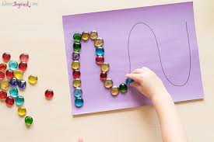

**Placing beads**

Draw some different shapes (these could be simple outlines of things your child likes e.g. cars). Then provide them with beads, sequins or counters to place carefully along the lines. You could have the same pattern each and race each other to see who can cover theirs first.

**Scoop and Transfer**

Set up a tray (to keep the mess contained!) with rice/lentils/couscous, and ice cube tray or cupcake tray and a scoop. Your child will just enjoy investigating this or again you can add a timer into the activity to make it more of a challenge – how many can you fill in 10 seconds?

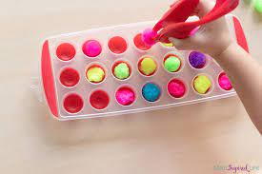**Pompoms and tweezers**

Provide your child with pompoms, large tweezers and an icecube tray or cupcake tray. Ask them to transfer the pom poms one at a time into the tray. This is another activity that you can add a timer into for extra challenge.

**Dough Disco**

Have some playdough at the ready (it’s easy to make if you don’t have the ready made stuff). Put on a play list of your child’s favourite songs and use them to have a fun dough disco! There are lots of different versions of these on youtube.

**Teeny tiny sponges**

Cut up a kitchen sponge into very small pieces and make them damp. Draw some different shapes (these could be letters if practicing letter formation) with chalk on a chalkboard or an outside patio area. Ask your child to trace what you have drawn using a damp sponge piece pinched between their index finger and thumb.