Haddenham St Mary’s half termly topic web Year Group: 1 Term: Spring 1
WOW Day
Wearing our favourite clothes.
Introduction to the topic activities

D.T
Sewing
Weaving
Fabric collage

History
Clothes through the ages – timeline of fashion
Victorian Fashion
Queen Victoria

Instruction
Science
To group materials by properties
To describe properties of different materials
To identify materials that objects are made from
To plan and carry out an investigation in groups
To identify natural and man -made materials
To understand the term ‘waterproof’

All Dressed Up!
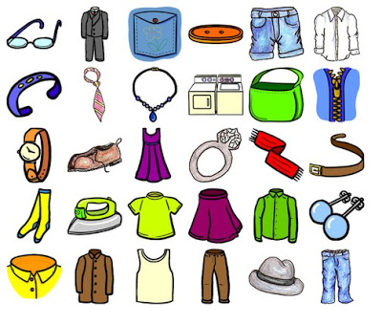
Geography
Clothes from around the world
Naming and Locating hot and cold countries on the map
Clothes for different weathers

RE
Special places
Places of worship

English
Instructions
Traditional Tales – Emperor’s New Clothes, Elves and the Shoemaker
Poetry
Computing
To collect data and create pictograms

