Dear Parents and Carers,

We have subscribed to https://spellingframe.co.uk/ for Sunshine Classes to support spelling at home.

Your child has a username and password to use when you log in to the website.

Spelling Frame allows you to practise the spellings we have set for the half term by entering a word list code on your ‘Home’ page. For this half term the code is 58237
↙

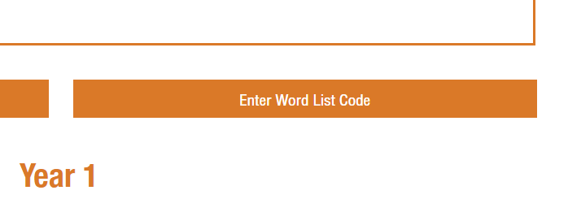

You will have the option to practise these words in the ‘spelling tiles’ activities, play games, and practise typing the words and complete a test of the words. You can also select Year 1 on your home screen and practise any of the phonic sounds we will be working on throughout the Year.
For example:

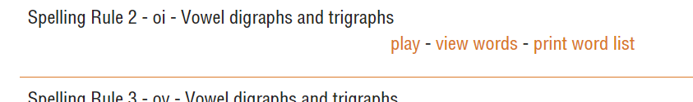

Your dashboard page shows the spelling points your child has earned through completing activities, tests and games – the class teachers can also see these scores, but the children are not able to see each other’s scores. There is also an option to click on a test we have set up of the spelling words for the half term which you can compete once your child has practised the words if you would like to.

We hope you will enjoy doing the activities with your child and find it beneficial for their phonics and spelling learning.

The Sunshine Team

