Oxford Owl Home Reading September 2020
(Phases 2, 3, 4, 5)
https://www.oxfordowl.co.uk/

Scroll down and click on ‘eBook Library for Letters and Sounds My Bookshelf’
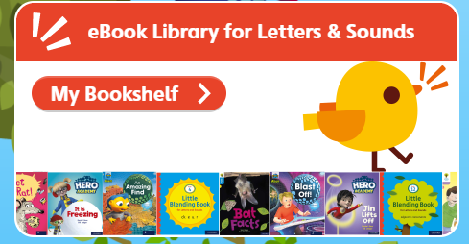
Select the Letters and Sound Phase your child is working at under ‘Levels’
You can explore other reading books by clicking on eBooks My Bookshelf in Green as shown below.
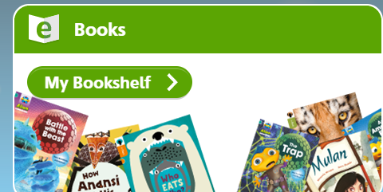
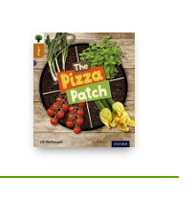
You can also select different stages within the levels selection tab to find more books.

