Sunshine Class Home Learning Week 3 (15.6.20)
You can sign up for a free Twinkl account to access many resources using this link and offer code:
https://www.twinkl.co.uk/offer offer code UKTWINKLHELPS
The website Phonics Play is also offering free access for parents and children
https://new.phonicsplay.co.uk/ Username: march20 Password: home
English and Phonics | Maths | Topic / Science / RE / Music
Look at this picture (there is a larger one at the bottom of this document). Can you write some questions you would like to find out about this person?  Leave some space after each question to add in the answers as you learn more tomorrow.  Remember to start your question with a capital letter and end it with a question mark.  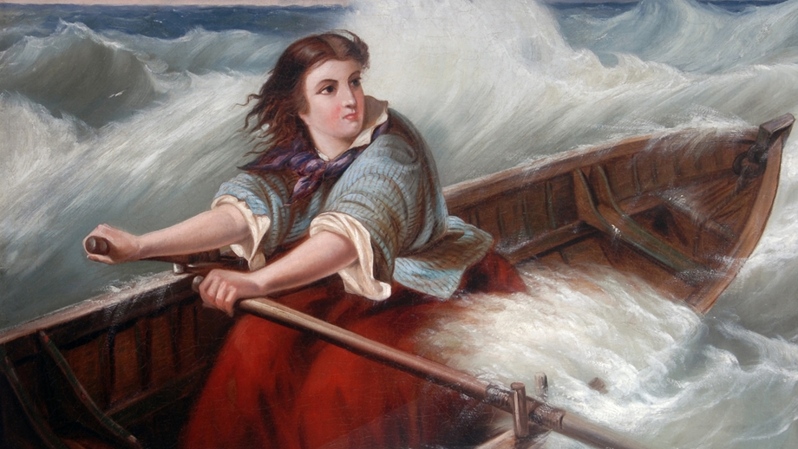  There is a BBC Bitesize lesson with activities if you would like to do more on question writing.  https://www.bbc.co.uk/bitesize/articles/zpshjsg | Find something in your house you could use to measure with. They all need to be the same size e.g. counters, lego bricks, paper clips. Choose some larger objects, such as a toys or books. Estimate how many small objects long each will be and then use them to measure what the length actually is. Can you find different things round your house which are longer and shorter? | Have a look at your seaside picture and write a list of the features. Talk about whether each one is natural (physical) or man-made (human). For example: a pier is a human feature because it has been man-made. Cliffs are a physical feature because they occur naturally. Can you sort your words into 2 columns?  Here is a power point which may help you to understand what human and physical features are  https://www.twinkl.co.uk/resource/t-tp-896-ks1-physical-and-human-geography-glossary-powerpoint (also attached to the email)  Try this quiz about the features of the seaside:  https://www.educationquizzes.com/ks1/geography/coastline-features/
Find out who the person in the picture is by watching this short video:  https://www.youtube.com/watch?v=xCL1x7wHQLY  Look back at your questions from yesterday, can you write in some of the answers?  If you like Horrible Histories this is a great video clip to watch about Grace Darling.  https://www.youtube.com/watch?v=x1mPbzDrav8 | The standard unit of measurement we use to measure length is a ‘centimetre’ which we shorten to ‘cm’ when we write it down. Find a ruler or tape measure and look at what a centimetre is. Practise measuring the length of small items using centimetres. Write down what each item measures. What was the longest item you measured? What was the shortest? Remember to put the end of the object at 0cm on the ruler / tape measure. | Continue to learn notes and sing along to some familiar songs in the next “handbells without handbells” music lesson!  https://www.youtube.com/watch?v=HdRkFFdkhm4&list=PLN3OIjekll41oCDuoW83bEEqXU67GXRlR&index=3
Grace Darling lived in a lighthouse. Can you find out some facts about lighthouses? What do you think it would have been like for Grace to grow up in a lighthouse? Can you find the Farne Islands on a map of the UK?  https://www.bbc.co.uk/cbeebies/watch/my-story-grace-darling  There is also lots more information about Grace Darling on the museum website, with some activities you can download and print, and a virtual tour of the museum, which is situated in Bamburgh, Northumberland. | 100cm makes 1 metre. We use metres to measure longer lengths. We shorten the word ‘metre’ to ‘m’ when we write it down. Use your ruler or tape measure to mark out how long 1 metre is. Can you find things around your home and garden that are longer and shorter than a metre? Make a table showing what you have found. | Can you make a lighthouse? Be as creative as you can! We would love you to email a picture of your lighthouse.
A compound word is where 2 words join together to make a new word. Watch the information and do the activities here:  https://www.bbc.co.uk/bitesize/topics/zcgv39q/articles/z38t6fr  Can you write down any more compound words you can think of? | Follow this link and print out the first activity. Use your ruler to measure and compare the length of the chocolate bars using cm. You can try the second activity and measure the width of the bars as well if you would like to.  https://content.twinkl.co.uk/resource/06/99/t-n-7568-ks1-chocolate-bar-measuring-activity-sheet-_ver_2.pdf?__token__=exp=1591193730~acl=%2Fresource%2F06%2F99%2Ft-n-7568-ks1-chocolate-bar-measuring-activity-sheet-_ver_2.pdf%2A~hmac=701c1373bbadf1b1f163f9cd60ccaf5a988a5dcedf79792cf1d37172b1f7a3ca  This activity is also attached to the email. | Look at your weather chart from last week. Can you write or film a weather report for one of the days?
Can you remember all the different ways the ‘igh’ sound is made when we read and spell words? Make a list, and think of some examples of words for each way. There are some activities you can do to help with this here:  https://new.phonicsplay.co.uk/resources/phase/5/alt-spellings-igh | Answer this reasoning puzzle:  (There is a larger picture at the end of the document)  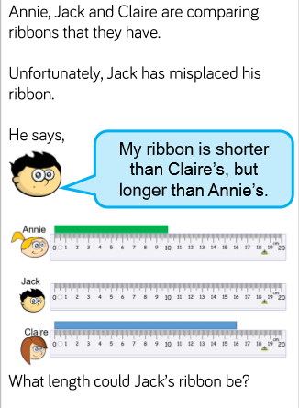 | Moses was an important Jewish leader. Watch this video about his life and how he helped to save his people.  https://www.bbc.co.uk/teach/class-clips-video/religious-studies-ks1-the-jewish-story-of-moses/zmfp382  If you have a bible see if you can find the story of Moses to read. Can you write some adjectives to describe what kind of leader Moses was?  You may recognise this song about Moses we sometimes sing in Collective Worship!  https://www.youtube.com/watch?v=Ne9hcc0_U5o

