SCHOOL UNIFORM

As Mrs Collett has already stated, guidelines will be relaxed slightly during September due to the current situation.

Your child will need a school uniform which is:
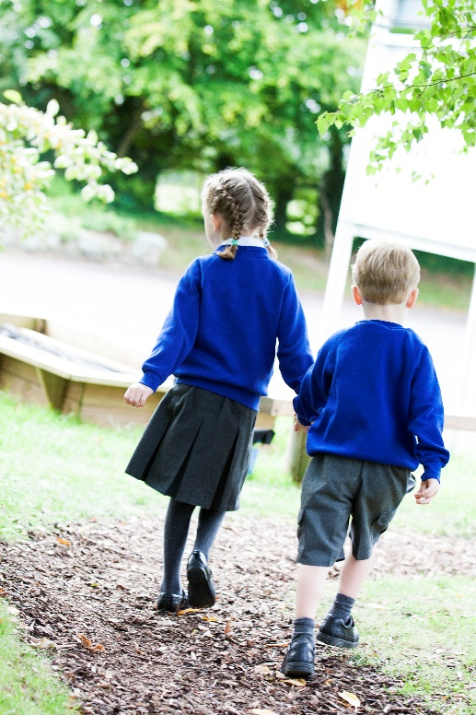
- Grey skirt, pinafore dress, trousers or shorts
- White blouse, shirt or polo shirt
- Royal blue cardigan, jumper or sweatshirt
- Blue and white gingham dress (in warm weather)

PE
For PE children will need a school PE t-shirt, plimsolls and shorts in a drawstring bag which they will hang on their peg in the cloakroom. In the winter children will need a warm tracksuit for outdoor PE lessons. For Reception children please include in the bag a spare pair of pants in case of accidents.

For PE lessons indoors, the children have bare feet and outdoors plimsolls are worn. Long hair must be tied back for safety.

You may wish to take your child’s PE kit home half termly for washing. Please take the opportunity to check for items which may have been mixed up or mislaid!

Jewellery
Children should not wear jewellery or watches in school.

The Print Lab Uniform (By appointment only during COVID-19)
School sweatshirts, cardigans, knitted jumpers, white polo shirts, fleeces, PE t-shirts, PE shorts, and PE bags are available to buy from PL School Wear in Aylesbury. For more information and to book your appointment please visit their website on: https://plschoolwear.co.uk/
Our PTA kindly give every child at school a book bag when they start school so you will not need to buy one.

Nearly New Uniform
We keep a selection of nearly new uniform in school. Due to the Coronavirus, this service is currently unavailable. We will let you know as soon as we reinstate it. Nearly new uniform is also on sale at PTA events during the year.

Please ensure that all items of uniform are clearly named, children tend to forget where they put their jumpers/cardigans and a clear name almost always ensures it is quickly returned to them. Lost property will be kept in the Reception cloakroom area until the end of term.

