Float or Sink
Draw or write the name of your object then think about whether it will float or sink. Tick the box you think. After you have made your prediction test it out. Don’t forget to fill in your results. Were you right?
Object | Prediction |  | Result
 | Float  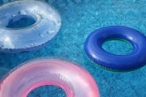 | Sink  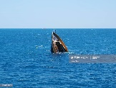 | Float | Sink

Challenge: Is there a way you can make the ones which sank, float?

