Early Years Home Learning Summer 2, Week 3, 22.06.20
STORY OF THE WEEK: The Water Princess by Susan Verde
These tasks are on Education City
These tasks will need some adult input/support
These tasks could be completed independently by your child once they are given the instructions.

Personal, Social and Emotional Development (PSED) | Communication and Language  (C&L) | Physical Development (PD)
Making relationships (ELG )  I can show sensitivity to others’ needs and feelings  The water Princess:  https://www.youtube.com/watch?v=xufbn6Ouu5U  The Real Water Princess  If we were in school I would share this video as I think it’s a great opportunity to have a glimpse into the life of a different culture and who better than the water princess herself. Although much of it might be ‘over their heads’ there are times where the video can be paused and you and your child can discuss the main points.  https://www.youtube.com/watch?v=i0B7ss_fIZc  Here is a brilliant video by Water Aid, which explains very well the need for access to clean water around the world. A great watch!  https://www.youtube.com/watch?v=UzRdJc-vPjM&list=PLc-oawSTlDS1PfrZZVSRDs4s1nPcVeaEM&index=2&t=0s  How would you feel if you were the Water Princess? Would you be happy to get up early EVERY day? Do you think she was happy in the story?  Can you make a list of all the things you are grateful for? Maybe you could draw some pictures and label them! What things on your list do you actually need to survive and what things are we lucky to have as special ‘luxuries?’ | Speaking (ELG+)  I can recount experiences and imagine possibilities, often connecting ideas. I can use a range of vocabulary in imaginative ways to add information, express ideas or to explain or justify actions or events.  This objective will be covered when talking about this week’s story and the supporting videos. See if the children can make links between the Water Princess’ life and their own, connecting ideas when talking about her. | Moving and Handling (ELG+)  I hold paper in position and use my preferred hand for writing, using a correct pencil grip. I am beginning to be able to write on lines and control letter size.  We will continue with this objective for the rest of the term. A lot of children can be reluctant to write at home so here are some writing opportunities they might be more willing to try!  Shopping list (with treats)!  Clues for a treasure hunt  Letter to a friend  Birthday/greeting card  Recipe for cakes/biscuits?  Instructions for how to play a game they have created?  Ask a grown up to draw some different patterns on a sheet of paper, zig-zags, waves etc. Carefully use some scissors to cut exactly on the lines. Can you stay on the line without wobbling off? Are you able to use the scissors safely? You could then draw your own lines, or perhaps you could draw an animal to cut out to make a collage?  Health and Self-Care (ELG+)  I know about, and can make healthy choices in relation to, healthy eating and exercise  Cosmic Yoga: Jamie is off to Tanzania! Lulu the Lioness!  https://www.youtube.com/watch?v=ZvJH8Kbzj54
Literacy  (L) | Mathematics  (M) | Understanding the World (UW)
Reading (ELG+)  Our book this week is:  The Water Princess  If you don’t have the book, here it is:  https://www.youtube.com/watch?v=xufbn6Ouu5U  Can you re-tell the story of The Water Princess to someone else? Why do you think she was given that name? How was her life different from yours?  You could look at some other Africa related books on Oxford Owl  https://www.oxfordowl.co.uk/home/reading-site/find-a-book/library-page?type=book&view=&query=Africa  Rainbows – try to practise your reading at least four times this week. It’s really important to keep practising this especially this term!  If you don’t have any appropriate books, remember the Oxford Owl website which is fantastic!  https://www.oxfordowl.co.uk/api/digital_books/1232.html  Phonics  I can read phonically regular words of more than 1 syllable as well as many irregular but high frequency words  Try these phonics lessons from letters and sounds:  https://www.youtube.com/watch?v=iXdE-JtYuGo&feature=youtu.be  https://www.youtube.com/watch?v=vEXXQ4pPrXY&feature=youtu.be  Try phase 2 and 3 tricky word trucks… click on phase 4 if you are up for a challenge!  https://new.phonicsplay.co.uk/resources/phase/4/tricky-word-trucks  Education City –  Sparkler  Jungle Beats  The Weather  Tricky word song for Phase 2  https://www.youtube.com/watch?v=TvMyssfAUx0  Tricky word song for Phase 3  https://www.youtube.com/watch?v=R087lYrRpgY  Phonics play – sound checker!  https://new.phonicsplay.co.uk/resources/phase/3/flashcards-speed-trials  Phase 2 sounds: s,a,t,p,i,n,m,d,g,o,c,k,ck,e,u,r,h,b,f,ff,l,ll,ss  Phase 3 sounds: j,v,w,x,y,z,zz,qu,ch,sh,th,ng,ai,ee,igh, oa,oo,ar,or,ur,ow,oi, ear,air,ure,er  (Rainbows)  Writing (ELG+)  I can use key features of narrative in my own writing.  Water Aid Poster  Could you design a poster to help Water Aid? You could draw a picture of someone walking to a well, or perhaps a picture of the people from Water Aid helping a village? Can you write some sentences to go with your picture? Perhaps you write why it is important for everyone to have clean water. Maybe you could think of something we could do at school to help Water Aid to help more people in need. I’d love to see your posters and read your ideas! | Number (ELG)  I can solve problems, including doubling, halving and sharing  Odd and Even Numbers  Children will begin to understand that quantities which can be shared into two equal groups with none left over are even. Those which have one left over are odd. You could demonstrate this with anything, a handful of lego blacks, sharing sweets with a sibling (or grown up)! Pairing up odd socks etc – emphasise the word EQUAL, children particularly understand this in the sharing of sweets, toys etc and whether it is fair!  Practise sharing different numbers of objects (up to 20) and find out which numbers are odd and even. Can you notice a pattern? When you are counting up to 20 from 0 every other number is odd/even. You could write the numbers in two different coloured pens to highlight this.  The children could watch this episode of numberblocks: https://www.bbc.co.uk/iplayer/episode/b08r2l4d/numberblocks-series-2-odds-and-evens  Have a go at finding all the odd and even numbers on this game:  https://www.topmarks.co.uk/learning-to-count/coconut-odd-or-even  Education City:  Pattern Play  Odd or Even  Sharing Stickers | People and Communities (ELG+)  I understand that different people have different beliefs, attitudes, customs and traditions and why it is important to treat them with respect.  Water Aid – Click the link to watch a daily water walk  Water Walk  The World  I can describe some actions which people in my own community do that help to maintain the area I live in. (ELG+)  We have lots of people who help us to have a safe, clean home, with access to food and water. Water Aid helps others who aren’t as fortunate. Have a look and see if you can build one of these…. You might need some help!  How to build a ‘Tippy Tap’  https://www.wateraid.org/uk/sites/g/files/jkxoof211/files/schools-challenge-ks1-tippy-tap-instructions.pdf  Do you have a globe or an atlas at home? If so, try to find Africa on it – how big is it? What countries can you see? Which countries do you think might find it harder to get water and why? How could you get to Africa?  Here’s a short clip about Africa from The National Geographic  https://www.youtube.com/watch?v=PSYHMWmyVfo  Technology (ELG+)  I find out about and use a range of everyday technology.  Log into J2E (Rainbows only)  Choose the ‘Animate’ tab create your own little movie. Choose a background and then add some animals perhaps? You could choose African animals and create a little journey? Or maybe to could make pictures like those in the story to show the Water Princess’ journey to get the water. Here’s one I’ve started:  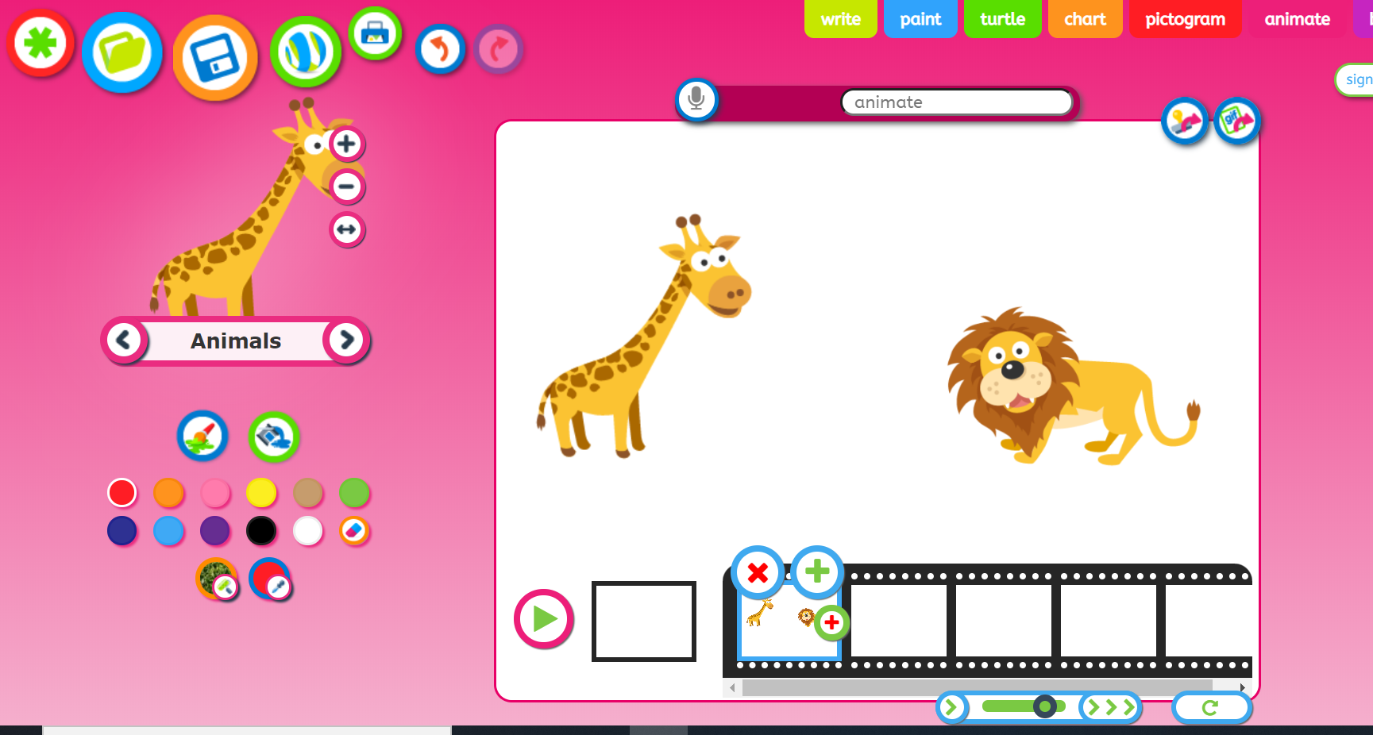  Remember to save your animation so we can log on to see it!
 | Expressive Arts and Design (EAD+)
Exploring and using media and materials (ELG)
I can sing songs, make music and dance, and experiment with ways of changing them
Have a go at drawing your own African animal. Can you remember what animals live in Africa? You might have seen them in some of the video clips. Here is a step by step video of how to draw an elephant if you want to try… remember you can pause the video and try to copy the artist. You could add some colours at the add and maybe draw the whole family of elephants:
https://www.youtube.com/watch?v=PCdm48P4bbo

African Dance:

Have a look at these children dancing, they’re fantastic and look so happy!
https://www.youtube.com/watch?v=berNlQW

See if you can make your own dance moves up to this African music. Does it sound like the music you listen to? What instruments can you hear?

https://www.youtube.com/watch?v=9b81mWYIyTo

