Early Years Home Learning Summer 2, Week 2, 08.06.20
STORY OF THE WEEK: The Rainbow Fish
These tasks are on Education City
These tasks will need some adult input/support
These tasks could be completed independently by your child once they are given the instructions.

Personal, Social and Emotional Development (PSED) | Communication and Language  (C&L) | Physical Development (PD)
Making relationships (ELG +)  I can play group games with rules. I understand someone else’s point of view can be different from mine. I can resolve minor disagreements through listening to each other to come up with a fair solution.  Play a board game with your family. What rules do you need to follow? Why do we need rules for games? How do you feel when someone breaks the rules? How do you feel when you lose the game? Try adding a new and different rule to your game, can you stick to it?  In our story this week (link below) the Rainbow Fish eventually realises what’s important and he feels better when he has shared his scales. Is there a time when you have shared something special? How did you feel? Perhaps you could write some sentences about what you shared and how you felt. Or you could draw a picture and label it!  Rainbow Fish Story:  https://www.youtube.com/watch?v=2jQTjTe42-0 | Understanding (ELG+)  After listening to stories I can express views about events or characters in the story and answer questions about why things happened.  Talk to someone about the story of the Rainbow Fish: Why did he not share his scales at first? Do you think the octopus had good advice? Why/why not? What do you think would have happened if he hadn’t shared his scales?  The children can answer similar questions about thoughts and feelings on characters and events from any other story you have read together. This really helps to develop their comprehension skills for later on.  Speaking (ELG+)  I can use a range of vocabulary in imaginative ways to add information, express ideas or to explain or justify actions or events.  Can you make a short video on why it is important to be kind, to share, to think of others. Maybe you could give me some top tips on the sorts of things I could do to help me be thoughtful? Perhaps you could ask your grown up to record your top tips and upload them to Tapestry! | Moving and Handling (ELG+)  I hold paper in position and use my preferred hand for writing, using a correct pencil grip. I am beginning to be able to write on lines and control letter size.  This week when you are writing any of the sentences or practising your handwriting, try to do it on lined paper. If you don’t have lined paper ask your grown-ups to draw some lines for you. See if you can sit each letter on the line. Try not to let them float away!  Remember to be using tripod grip, (pinchy fingers), super important now we are writing more!  Cosmic Yoga: Squish the fish!  https://www.youtube.com/watch?v=2cNjAj_o0SI  The weather doesn’t look great for this week. If you’re stuck indoors why not try this Indoor Fitness Scavenger Hunt!  (document attached to email/on website)  Health and Self-Care (ELG+)  I can dress and undress independently, successfully managing fastening buttons or laces  If you are managing to get out of your pyjamas each day well done!! See how quickly you can change into something a little tricky, a shirt with buttons or shoes with laces. Try to practise hard to learn a new skill, like tying your laces, buttoning a top button or zipping your coat. Please do show us your new skill when you’ve mastered it, we’d love to see!
Literacy  (L) | Mathematics  (M) | Understanding the World (UW)
Reading (ELG+)  I can describe the main events in the simple stories I have read.  Our book this week is  The Rainbow Fish  If you don’t have the book, here it is being read by the author:  https://www.youtube.com/watch?v=2jQTjTe42-0  Talk about what you liked in the story, how the Rainbow fish felt during different parts and why.  Rainbows – try to practise your reading at least four times this week. It’s really important to keep practising this especially this term!  If you don’t have any appropriate books, remember the Oxford Owl website which is fantastic!  https://www.oxfordowl.co.uk/for-home/find-a-book/library-page/  Phonics  I can read phonically regular words of more than one syllable.  Syllables  https://www.learninggamesforkids.com/vocabulary-games/syllables/syllable-lesson.html  Education City –  Snug as a bug  Meet an Alien  Pet Shop  Wheelie Wednesday  Tricky word song for Phase 2  https://www.youtube.com/watch?v=TvMyssfAUx0  Tricky word song for Phase 3  https://www.youtube.com/watch?v=R087lYrRpgY  Phase 2 sounds: s,a,t,p,i,n,m,d,g,o,c,k,ck,e,u,r,h,b,f,ff,l,ll,ss  Phase 3 sounds: j,v,w,x,y,z,zz,qu,ch,sh,th,ng,ai,ee,igh, oa,oo,ar,or,ur,ow,oi, ear,air,ure,er  Writing (ELG)  I use my phonic knowledge to write words in ways which match their spoken sounds.  Try and do a little bit of research on fish… perhaps you could look up your favourite fish. Maybe you have some books at home. Can you write some facts about them? You could make a little information booklet and draw some pictures too.  You could use these links:  Books on Oxford Owl:  https://www.oxfordowl.co.uk/home/reading-site/find-a-book/library-page?type=book&view=&query=fish  Fish Facts:  https://www.sciencekids.co.nz/sciencefacts/animals/fish.html  https://kids.kiddle.co/Fish  Videos:  https://www.youtube.com/watch?v=u_Xv5BRnflA | Shape, Space and Measure (ELG+)  I can estimate, measure, weigh and compare and order objects.  This week we are going to think about capacity. Go on a hunt around your house to find any different containers which could hold water. Try to find ones of different shapes and sizes. Check with your grown-ups that you are allowed to use them! Have a look closely at the containers and put them in order of how much liquid you think they can hold (from least to most)  Ask a grown up to help you work out if your order is correct. You could label your containers a, b, c etc and then just write the letters down in the order you think. (Adults, when measuring the capacity, the children to not need to use units, e.g. ml etc. they can simply see how far a container fills up a bucket, or how many cup fulls of water it takes to fill the container up).  Have a look at this simple powerpoint together:  https://www.twinkl.co.uk/resource/monster-milkshake-cafe-capacity-powerpoint-t-m-32007  Vocabulary to learn: full, empty, container, half full/empty, almost full/empty.  Or you could try this activity from nrich, a problem solving website….. similar to the above but focused on finding the best sized bottle  https://nrich.maths.org/12491  If you have access to a printer you could complete the capacity sorting sheet.  Education City:  Measure up  Capacity Instrument  Lemonade Stand  Pitcher framed – more challenging! | The World (ELG+)  I know the properties of some materials and can suggest some of the purposes they are used for.  This links to your EAD activity. Try to think about the best materials for your fish. Can you find one’s which are shiny? Bright? Easy to stick? Try to talk about the properties of each material, soft, rough, flexible etc and think about why your choices for your craft are good ones? Maybe there are materials you know would work better but you don’t have at home. Perhaps you could write a list of things you would use next time which we can get at school!  Technology (ELG+)  I find out about and use a range of everyday technology.  Be a technology spy, take a pen and paper and go on a hunt around your house. What technology do you have? Make a list or draw the items you see. You might find computers, tvs, mobile phones, fans, microwaves etc. I wonder what else you can find. Do you know what they all do? If not ask your grown up to explain what they are and how they’re used. See if your grown up can guess everything on your list! Did they forget anything?  Log into J2E (Rainbows only)  Use the Paint programme to create an underwater theme picture. Here’s one I did:  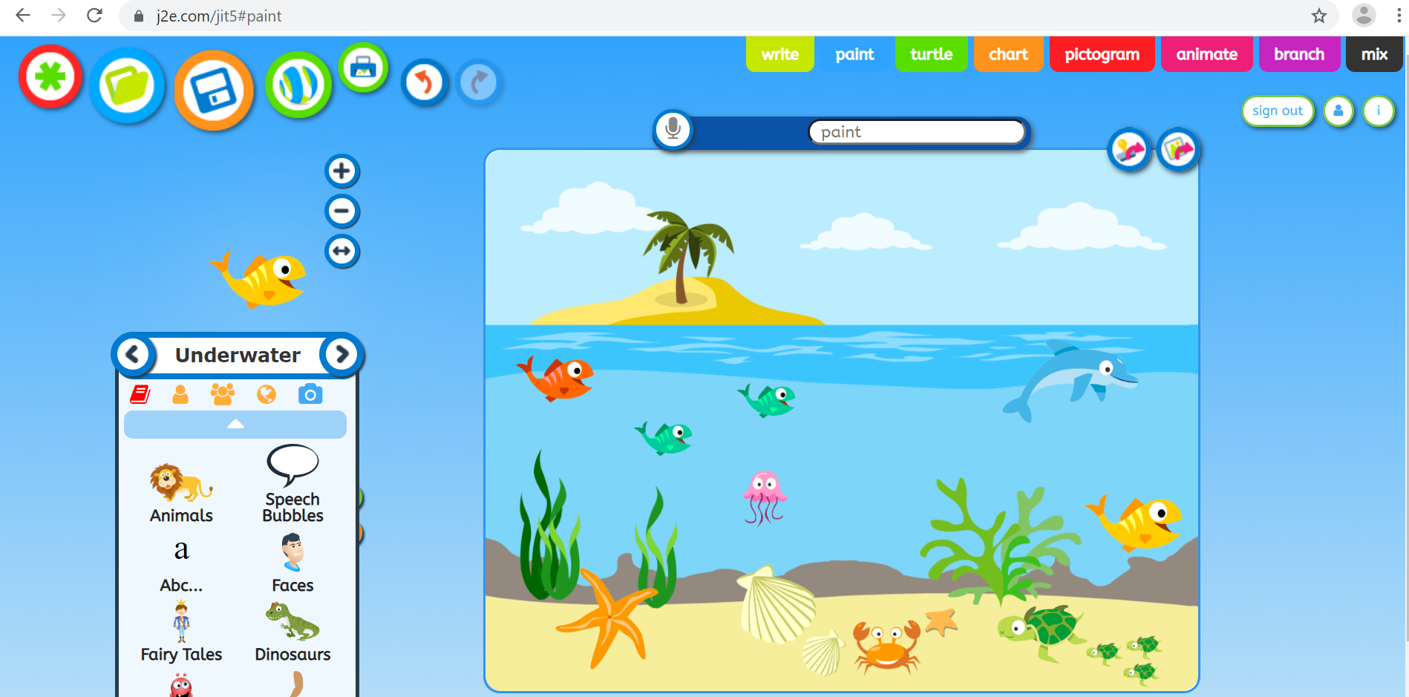  Remember to save your picture so we can log on to see it!
 | Expressive Arts and Design (EAD+)
Through my explorations I find out and make decisions about how media and materials can be combined and changed.

Have a go at making your own rainbow fish! Perhaps you could look through your recycling to see if there are any materials you can use from there. Think about how you might be able to make it bright, colourful and shiny! What materials work best? What colours might you use? If you have paints you might want to mix some colours and see what happens! We would love to see your fish so please do upload a picture to Tapestry!

See if you can follow this link and learn to draw a simple fish.
https://www.youtube.com/watch?v=QtGeB5tu2xU
You could make an underwater picture and add some other sea creatures or perhaps you could draw the Rainbow fish with his friends. If you wanted to, you could label your picture!

