Sunshine Class Home Learning Week 4
You can sign up for a free Twinkl account to access many resources using this link and offer code:
https://www.twinkl.co.uk/offer offer code UKTWINKLHELPS
The website Phonics Play is also offering free access for parents and children
https://new.phonicsplay.co.uk/ Username: march20 Password: home
English and Phonics | Maths | Topic / Science / RE / Music
http://www.primaryhomeworkhelp.co.uk/castles/index.html  https://www.youtube.com/watch?v=RXXDThkJ3Ew  https://www.twinkl.co.uk/resource/t-t-252558-castles-differentiated-fact-file  https://www.twinkl.co.uk/resource/t-h-80-parts-of-a-castle-powerpoint  Task: To research facts about castles.  Use any of the links above (or any of you own) to find out more about castles. You may even have a non-fiction book about castles at home.  Challenge: Write down any facts you find interesting. | https://www.youtube.com/watch?v=92u117zn-rc  Arrays in maths are an arrangement of objects or pictures in rows or columns.  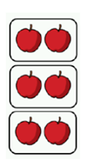  This helps us to visualise and understand repeated addition, multiplication and division.  Watch the video(link above) to find out more about arrays. In y1 we focus on repeated addition to start with.  Task: Have a go at arranging your own even number of objects into arrays and then count the groups to find the total.  2 + 2 + 2 =  Use the activity sheet on the sunshine page of the website as a guide of how to do this task. Remember each row of your array must have the same amount.  Alternatively, you can print the activity sheet and complete using the pictures or real objects to help you.  Talking points:  How many rows? How many objects in each row? What sum can you do to work this out? (repeated addition e.g 2+2+2 = is a good starting point) What is your total number of objects? How did the array help you work this out? | Research what a coat of arms is and design your own for your family.  You can use the templates from twinkl to put your coat of arms onto.  https://www.twinkl.co.uk/resource/t-t-198-design-your-own-personal-coat-of-arms
https://www.youtube.com/watch?v=a1UTcytfNxw  (When you watch the link above you can pause on different pages to look more closely).  Using your research from the previous task create your own non-fiction book (fact book) all about castles. Use the link above to look at how a non-fiction book is set out (or you may have one of your won to look at), it may also give you some ideas of what you want your book to look like! Try to include some of these features:  - A front cover  - Contents page  - A blurb at the back  - Pictures of a castle/parts of a castle with labels  - Facts and information about castles in sentences  Your book can include as many pages as you like. Just one page is absolutely fine. | Doubling is when we have 2 of the same amount. When we double a number we add the same number to itself like this: 2+ 2= 4.  https://www.youtube.com/watch?v=NDqbCfplYrg  We love Jack Hartman as a starter in our maths lessons. Click on the link to watch his video on doubling numbers.  Task: Teddy bears picnic!  You will need 2 teddies, 2 plates, 20 objects to use as their food at the picnic (anything from grapes, cheerios, sweets to counters, stones etc)  - Choose a number 1-10  - Put this amount on one plate for one teddy  - Now put the same amount on the plate for the other teddy. Remember each plate must have the same amount.  - Count how many the teddies have altogether. What is the total?  - Now write the addition sum  e.g 5+5 = 10  Challenge: can you try doubling numbers up to 20? | Listen to the musical story ‘The Grasshopper Song’ Can you join in with some of the words?  https://www.bbc.co.uk/bitesize/topics/zw2ntv4/resources/1  Can you think of any other songs that tell a story?
Proper nouns (specific names of people and places) need a capital letter. Can you write a list of people in your family, making sure their names have capital letters? Can you write a list of places (town, cities, villages, countries) you have visited or would like to visit, make sure they have capital letters also.  Challenge: now write sentences or even a short story using a selection of these names and places | Doubling Challenge  You will need: a stop watch (timer), a piece of paper, a pencil or pen  - Fold the paper in half  - Ask an adult to write up to 10 numbers 1-10 in any order on one side of the paper  - Set a timer  - Double the number and write the answer next to it.  - How quickly can you do it?  - Can you play again with the same numbers and beat the time?  - Can you try different numbers?  You can use objects to help you, remember you can also use your fingers to help!  Challenge: Follow the link below and print the doubling jungle race game. Play as our game above but these numbers are to 20.  https://www.twinkl.co.uk/resource/t-t-2546076-doubling-jungle-race-activity-sheet | https://www.youtube.com/watch?v=Da6lxY_8jmU  Follow the link above and listen to the story of Jasper’s Beanstalk.  Think about these questions and discuss them with your adult:  Why didn’t Jasper’s beanstalk grow after a week?  What do plants need to grow?  Did Jasper do some things that were right to help his bean grow?  Why do you think his bean grew in the end?  Challenge: Can you write a list of what a plant needs to grow?
https://www.ictgames.com/mobilePage/forestPhonics/index.html  At school we play forest phonics on the IPAD to help us revise our phonics and spell words.  Follow the link and choose which phoneme you would like to revise. Listen to the word they are asking you to spell and move the correct letters into place. How many stars can you get?  Challenge: try the split digraphs i_e, o_e, a_e | Butterfly doubles.  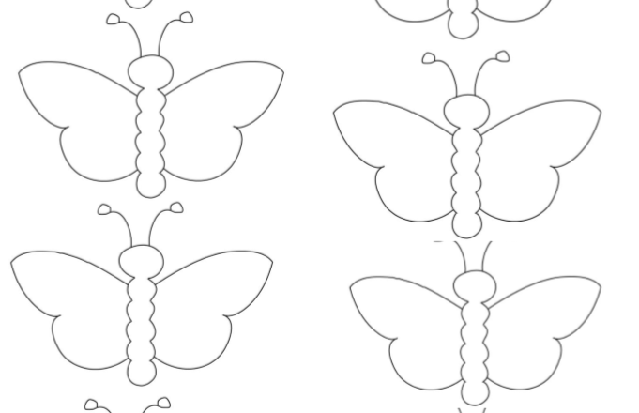  Print off the butterfly doubles activity sheet (see sunshine class page) or make your own butterflies in any way you like. You could even paint some!  Put a number of dots on one of the butterfly wings. Put the same amount on the other wing. What is your total? Write the sum under/on each butterfly.  Challenge: Double numbers to 20 | https://www.twinkl.co.uk/resource/t-t-5231-bean-life-cycle-powerpoint  We would be planting our own beans/plants at school about now. As we are unable to grow our own beans at school at the moment, click on the link and follow the Power Point to find out how a bean grows. This also includes a very interesting time lapse video of a bean growing (you may need to open this separately in order for it to play).  Can you tell your adult what happens when a bean grows.  What happens first? What comes next?  Task: Can you draw your own life cycle of a bean in 4 pictures.
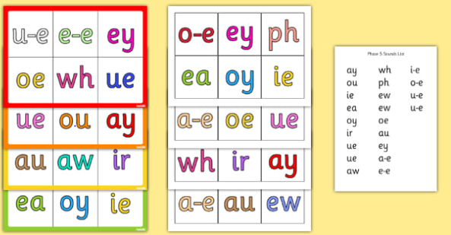  https://www.twinkl.co.uk/resource/t-l-4202-phase-5-phonic-bingo-and-lotto-game  Play phase 5 bingo with your family. You can print out the boards from the link above and I have also saved a pdf version on the sunshine page on our website. The mats with the coloured edge are for you to play with and the mats that are not coloured (duplicates) are for you to cut up, place into a box/bag and call out. Alternatively, you can make your own bingo game like we do at school.  Here is how:  - Write down all the phase 5 sounds (see phase 5 mat below), cut them up and put them into a box/bag ready for the caller to pick out a sound at a time.  - Each player selects 6 (or a number of your choice) different phase 5 sounds and writes them on a mini whiteboard or a piece of paper.  - As each sound is called tick it off on your board/paper and when you have all the sounds on your board/paper ticked off shout BINGO!  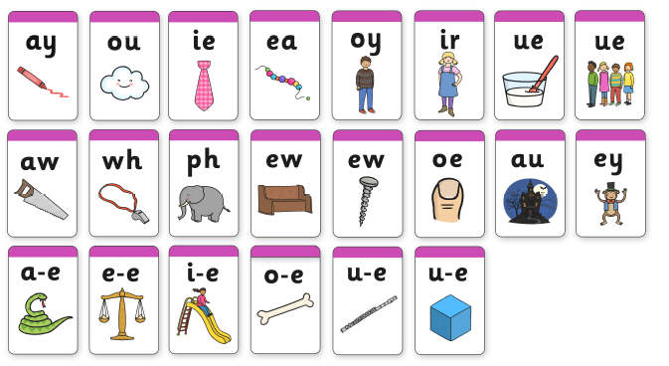 | Maths Investigation: If I double any number the answer will always be an even number. Do you agree?  Try investigating this. Double numbers and record the answer. Is the answer always even? Try doubling a range of odd and even numbers. What did you find out? | http://www.primaryhomeworkhelp.co.uk/castles/motteandbailey.htm  Did you know there are different types of castles?  Follow the link and see if you can find out more about these types: Concentric, motte and bailey and stone castles.  Which is your favourite type of castle? Can you draw it and label its special features.

