Rainbow Class Home Learning Week 5, 18.05.20
STORY OF THE WEEK: THE SNAIL AND THE WHALE, Julia Donaldson
These tasks are on Education City
These tasks will need some adult input/support
These tasks could be completed independently by your child once they are given the instructions.

Personal, Social and Emotional Development (PSED) | Communication and Language  (C&L) | Physical Development (PD)
Managing Feelings and Behaviour (ELG)  I can understand and follow rules  Making Relationships (ELG)  I can play cooperatively, taking turns with others.  Choose a favourite board game to play with members of your family. If you don’t have a game, you could play hangman or noughts and crosses. Can you take turns? Are you able to let someone else be first to start the game? Even if you are upset when you lose, can you end the game nicely? See how you get on, I bet you can do all these things! | Understanding (ELG)  I can follow instructions involving several ideas or actions.  Play a game of ‘Simon Says’  Well, it could be ‘Spiderman says’ or ‘Princess says’, whatever character motivates you!  Ask an adult to start simple with one instruction (Princess says ‘jump’!), then increase to two or three instructions (Superman says “jump, turn around three times, then sit down!”)  Then it’s your turn to give the instructions (dress up as your character!) They could be really silly instructions as long as they are safe – “put a hat on, sit on the floor and rub your tummy twice!”  In this game you need to listen to the instructions to build homes for different animals.  https://pbskids.org/arthur/games/animal-home-builder | Moving and Handling (ELG)  I can use a pencil and hold it effectively to form recognisable letters, most of which are correctly formed.  Can you write a card, note, letter or story for a relative or friend, using your very best handwriting and holding your pencil correctly?  I can show good control and co-ordination in large and small movements. I can move confidently in a range of ways, safely negotiating space  BBC Radio: Minibeast Dance part 2  https://www.bbc.co.uk/sounds/play/b03g6vs7  Cosmic Yoga:  Stella the Stick Insect  https://youtu.be/wBdMZMEKq-s  Health and Self-Care (40-60)  Practises some appropriate safety measures without direct supervision  Cooking: Try making some minibeasts biscuits, or perhaps you could make some butterfly cakes… how can you keep yourself safe?
Literacy  (L) | Mathematics  (M) | Understanding the World (UW)
Our story this week is  The Snail and the Whale by Julia Donaldson  Book:  https://www.youtube.com/watch?v=G_8QS_nyzM8  Movie:  https://www.bbc.co.uk/iplayer/episode/m000cslw/the-snail-and-the-whale  Phonics: I can blend sounds to make words.  Buried Treasure game:  Read the words, drag them to the treasure chest if they are real or the bin if they are ‘fake’. Try ‘all of Phase 3’ or choose the sounds you find tricky.  https://new.phonicsplay.co.uk/resources/phase/2/buried-treasure  I can read some common irregular words:  Confident with your Phase 2 & 3 sounds and tricky words? Then challenge yourself to try learning some Phase 4 tricky words.  A song to help you learn Phase 4 tricky words:  https://www.youtube.com/watch?v=3NOzgR1ANc4  Play this game to practise reading Phase 4 tricky words  https://new.phonicsplay.co.uk/resources/phase/2/tricky-word-trucks  Phase 2 sounds: s,a,t,p,i,n,m,d,g,o,c,k,ck,e,u,r,h,b,f,ff,l,ll,ss  Phase 3 sounds: j,v,w,x,y,z,zz,qu,ch,sh,th,ng,ai,ee,igh, oa,oo,ar,or,ur,ow,oi, ear,air,ure,er  Reading (ELG)  I can demonstrate understanding  Can you talk to an adult about a book you have read? Tell them which is your favourite part and why.  Ask your parent/carer to write a list of objects that are around your home. Then head over to the Technology section of this page and use your device to take a photo of each object as you read it from the list.  Education City - Captain’s Log  Seaside Story  Writing (ELG)  I can write sentences which can be read by myself and others.  At the end of The Snail and the Whale all the snails climb onto the whale’s tail. Can you write a story about where they might go? What will they do? What will they see? Who will they meet? When you have written your story, try reading it out loud to your family and then maybe they can read it themselves. You could draw a picture to illustrate your story too! | Number: I can solve problems including doubling and halving. (ELG)  I can add two single digit numbers and count on to find the answer.  Practise adding anything you can.... put into two groups (e.g. 3 forks and 5 knives) and find out how many altogether. Do we need to count the forks? Can we see there are 3 already? We can just count on from 3 to find the answer! What else can you add together in your house? What happens to the total when we add (he gets bigger)  You could look at this power point together:  https://www.twinkl.co.uk/resource/t-n-2546271-counting-on-addition-to-20-powerpoint  Try this game:  https://www.topmarks.co.uk/addition/robot-addition  Education City:  Counting Carnival | The World (ELG)  I can talk about how environments might vary from one another  Watch this lovely clip showing lots of different minibeasts in their habitats. DO they all live in similar places? Can you think of some minibeasts which don’t live in this country? Why don’t they? See if you can research a minibeast from a different country and think about how their habitat is different from a snail’s in you garden! You could draw and label the minibeasts you have researched!  https://www.bbc.co.uk/bitesize/clips/z44g9j6  Here’s your weekly visit from Jess to tell you all about snails and slugs  Snails:  https://www.bbc.co.uk/cbeebies/watch/mini-beast-adventure-with-jess-snail-adventure  https://vimeo.com/92751571  Technology (ELG)  I can select technology for a particular purpose.  What could you use in your house to take a photo? (phone, iPad, camera)!! Ask a grown up if you can choose something to take some pictures with. See if you can find a snail, or any other minibeasts in your garden or whilst on your daily walk. Remember to look carefully under plants and logs to see if they are hiding!  Log into J2E and select the ‘turtle’ tab. You can select the flower background and a butterfly appears which you can programme. Decide where in the garden you would like it to fly and send it on a little adventure by choosing the correct arrows. Did it move where you wanted it to go?  Here is the link:  https://www.j2e.com/jit5#turtle  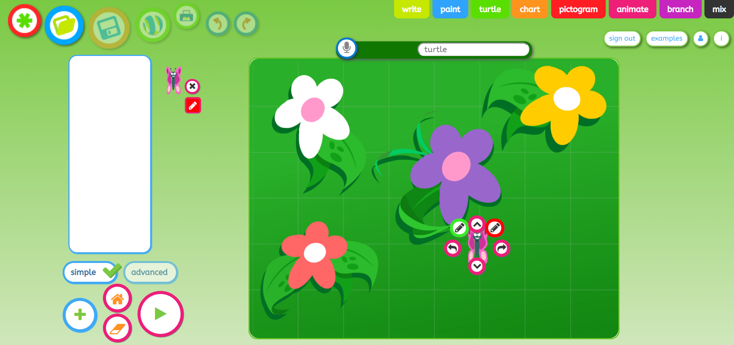
 | Expressive Arts and Design (EAD)
Being Imaginative
I represent my own ideas, thoughts and feelings through design and technology, art, music, dance, role-play and stories. (ELG)

Henri Matisse was a famous French artist. He made a HUGE picture called ‘snail’ using cut out paper shapes. Can you make your own version? Or you could make a picture of a different minibeast using the same technique!
See his picture and learn how to make your own here:
https://www.tate.org.uk/kids/make/cut-paste/collage-matisse-snail

Can you open a café at home? Your guests could be your teddies and toys, your siblings or adults in your home. Welcome them into your café, show them to their seat, explain what is on the menu (can you write one?) and serve them their food.

