Sky Class Home Learning Week 2
W/B 27th April
You can sign up for a free Twinkl account to access many resources using this link and offer code:
https://www.twinkl.co.uk/offer offer code UKTWINKLHELPS
The website Phonics Play is also offering free access for parents and children
https://new.phonicsplay.co.uk/ Username: march20 Password: home

English | SPaG/Phonics | Maths | Science/ RE/ Computing/ Topic
Describe a setting  Read ‘Toby and the Great Fire’ up until Page 15 “Then he saw a terrible sight” .  What do you think Toby could see? Have a look at the pictures from the book, and use Google to see some others.  Write a detailed description about what you think he could see/hear/smell.  Use adjectives to help describe the setting.  Here is the link to the book: https://docs.google.com/presentation/d/1SJiAmZ8r3NII09QG4ytn_bKqxrEiU3PDl4jwD2OjVy8/edit?usp=sharing | Using contractions  Two words can be squashed together to make one word, for example: 'I am' can become 'I'm'. Log onto 'Education City' and watch the 'Learn Screen' entitled 'Force Field: Apostrophes for Contractions' which explains further. Play the 'Croaking Contractions' and 'Force Field' games, then complete the 'Force Field' worksheet (answers also available). | Number Bonds/Times Tables  Start the week by revising your number bonds, times-tables and/or doubles and halves.  If there is something you are finding difficult, keep going!  https://www.topmarks.co.uk/maths-games/hit-the-button  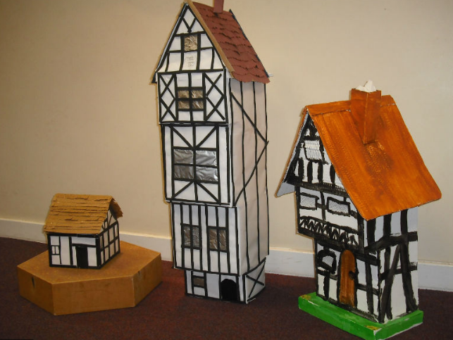 | Great Fire of London Timeline  Using the information you found last week, can you make a timeline outlining the key events?  Include the date and time (if you know it) of what happened. You can either write or draw pictures to show what happened.  If you fancy a more creative task this week, try to make a house using any junk modelling things you have at home!
Write a diary  Finish reading ‘Toby and the Great Fire’ Today, you are going to write a diary entry pretending to be Toby.  Use the description you wrote and have a think about what Toby could see that day? Hear? Smell? What would he have been feeling?  Make sure you focus on writing it clearly and making it interesting and not just getting to the end of the day! | Adding ed to words  We add the suffix ‘ed’ to words when we are making them past tense (something that has already happened)  There are some rules that we have to follow when adding ‘ed’ to words:  Over the next few days, work your way through the worksheets provided, they will explain the rules to you. If you are finding it difficult, don’t move on to the next sheet until you are happy with it!  https://drive.google.com/file/d/1mvxauXOgOD0AQ7ROk0P1Eel0ck2qy4c1/view?usp=sharing | Addition  Log onto education City and look through the ‘Addition Learn Screens’ part.  This will explain how to complete addition questions.  (It might be a good idea to do these with an adult. It works through 3 different levels, so stop where you think it is appropriate from your child & if there is time, maybe try a few addition number sentences together) | Parts of Plants  Find out parts of the plant and the jobs they do by looking through this PowerPoint  https://docs.google.com/presentation/d/1EEdKwU9ikpKhRTMTzeJUY3soHxH4KOBv33rM4JLYS_8/edit?usp=sharing  Then draw a plant and write about the jobs each different part does.
To read and answer questions  Today is a comprehension task.  Read the factfile all about The Great Fire of London and answer the questions about it.  https://drive.google.com/file/d/1Ex_2_6SlkviTqAiX3cYnKpyIs2oDV4xf/view?usp=sharing  Remember that there are no trick questions, so if you can’t find the answer then re-read the text. Try writing your answer in full sentences.  (Parents, there are 3 ability texts available. Have a read and judge which one you think is a suitable challenge for your child)  If you don’t have access to a printer, you could use this online comprehension on Twinkl:  https://www.twinkl.co.uk/go/resource/tg-e-13-the-great-fire-of-london-differentiated-reading-comprehension-activity) |  | Addition  When you have used the learn screens to help you remember how we do addition, use the ‘Addition activities’ and work your way through the activities provided on there.  If you can’t access Education City, ask a grown up to write you some number sentences.  Addition  Here are some addition worksheets for you to work through:  This is addition of 2 two digit numbers: https://drive.google.com/file/d/16OzKQ5VR0y81dr77THU2Wr4yaKWodf72/view?usp=sharing  This is a challenge sheet, where regrouping is used:  https://drive.google.com/file/d/1dPRG2jgvUWv9Pi3BTfpqF681oLLFdFI8/view?usp=sharing | Roles and Responsibilities  Have a think about the adults in school and what different jobs they do.  Can you draw a picture of an adult in school and write about the roles they have to do (teaching children, cooking children healthy meals, keeping children safe)  We would love to see what you create!
Write from different viewpoints  Listen to 2 characters - https://www.youtube.com/watch?v=weEveQ4nz4g&safe=active , a cat and Samuel Pepys who are giving their account of what they saw on the day the fire started.  Pretend you are either the cat or Samuel Pepys and write about what you saw. Remember to write in the first person and use interesting words to help make it more interesting to read.  (Note- This doesn’t have to be written in a diary style.) | Addition investigation  Have a go at this investigation using your addition skills.  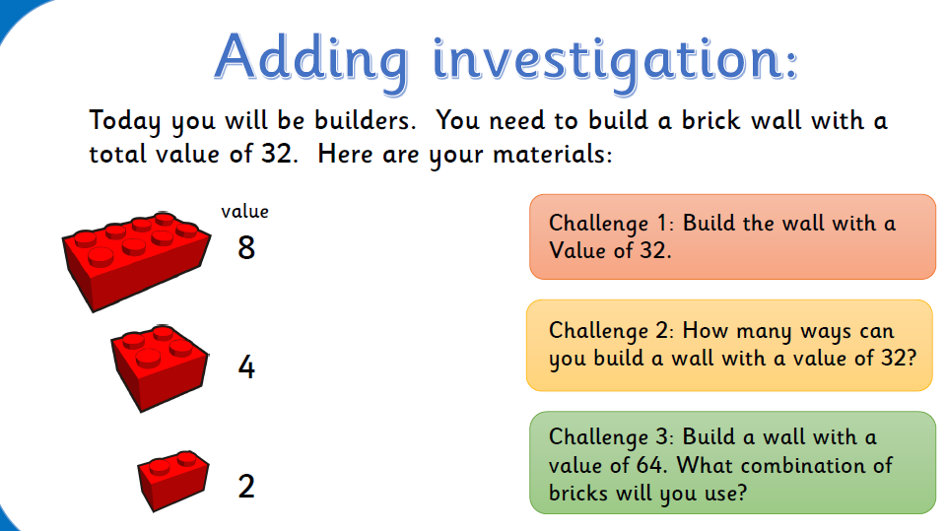 |  | Make an Animation  Log onto J2E  Go to JIT5  Go to animate (tab on the top right of the screen)  Choose a template  Have a play around how to get the different things to move across the screen.  Remember to save your work!

