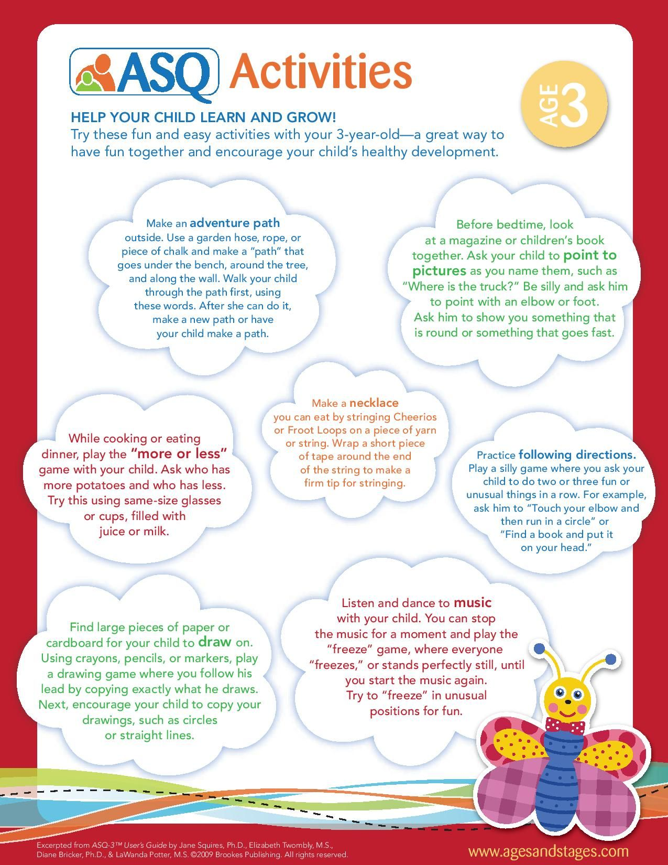

We hope that this is a starting point for you and your child.

Little Forest Friends

Ideas for having fun and learning with your child at home.