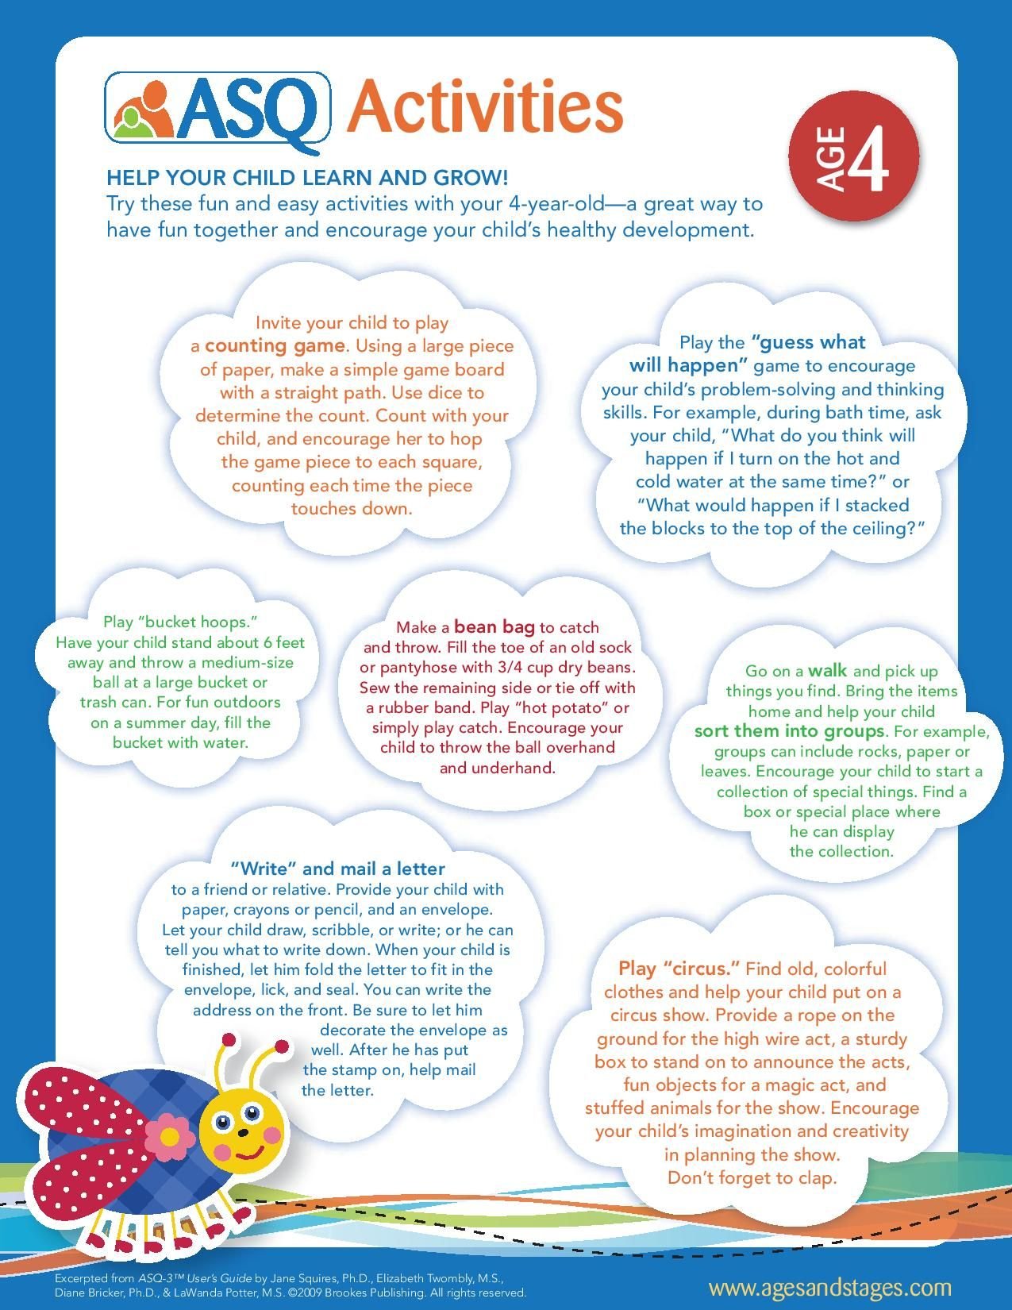

Little Forest Friends

Ideas for having fun and learning with your child at home.

wqqqqqqqq

We hope that this is a starting point for you and your child.