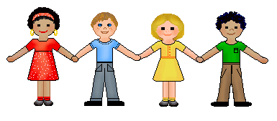[1]

**Literacy**

* **Reading:** Letters and Sounds
* **Writing:** Names, labels and captions (non-fiction)

Fine motor skills

Pencil grip

Role-play mark making

**What we will be learning…**

**Autumn 2019**

Guess Who?

(First 4 weeks)

**Personal, Social & Emotional Development**

* **Self-Confidence and Self-Awareness:** Being confident to try new activities and speak in a familiar group.

Learning the rules of the classroom and school

* **Managing Feelings and Behaviour:** What is right and wrong?
* **Making Relationships:** Form good relationships with adults and peers.

**Mathematics**

* **Numbers:** Counting

Numbers to 5

Number sense

Different representations of numbers

* **Shape, Space and Measure:**

Sorting

Patterns

**Expressive Arts and Design**

* **Exploring and using media and materials**

Colour mixing and self-portraits.

Recognise and explore how sounds can be changed.

Match movements to music.

* **Being imaginative:** Use their imagination in art and design, music, dance and imaginative and role play stories.

**Understanding of the World**

* **Technology:** Information Around Us
* **Communities:** Getting to know each other
* **All About Me –** Information Books.
* **When I was a baby** –timeline, differences.
* **The World –** Find out about their environment that they live in and the natural world. Be able to talk about the features that they like or dislike.

**Physical Development**

* **Moving and Handling:** Throwing & Catching, Balancing, Skipping.
* **Fine Motor Skills:** Dress dolls, zips, buttons and fasteners on clothes, drawing patterns on clothes, cutting hand prints etc.
* **Health and Self-care:** Recognising changes that occur when we exercise.
* **Healthy eating**
* **Becoming independent**: changing for PE.

**Communication & Language**

* **Listening and attention:** Listening to stories and rhymes with enjoyment.
* **Understanding:** Use talk to organise, sequence and clarify thinking, ideas, feelings and events.
* **Speaking:** Interact with others, negotiating plans and activities and taking turns in conversation.

1.