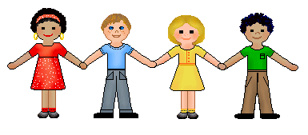[1]

**What we will be learning…**

**Autumn 2017**

Guess Who?

**Personal, Social & Emotional Development**

* **Self-Confidence and Self-Awareness:** Being confident to try new activities and speak in a familiar group.

Learning the rules of the classroom and school

* **Managing Feelings and Behaviour:** What is right and wrong.
* **Making Relationships:** Form good relationships with adults and peers.

**Expressive Arts and Design**

* **Exploring and using media and materials**

Colour mixing and self-portraits.

Recognise and explore how sounds can be changed.

Match movements to music.

* **Being imaginative:** Use their imagination in art and design, music, dance and imaginative and role play stories.

**Understanding of the World**

* **Technology:** Information Around Us, assembling text
* **People and Communities:** Harvest.
* **All About Me –** Information Books.
* **When I was a baby** –timeline, differences.
* **The World –** Find out about their environment that they live in and the natural world. Be able to talk about the features that they like or dislike.

**Physical Development**

* **Moving and Handling:** Throwing & Catching, Balancing, Skipping.
* **Fine Motor Skills:** Dress dolls, zips, buttons and fasteners on clothes, drawing patterns on clothes, cutting hand prints etc.
* **Health and Self-care:** Recognising changes that occur when we exercise.
* **Healthy eating**
* **Becoming independent**: changing for PE.

**Literacy**

* **Reading:** Letters and Sounds
* **Writing:** Names, labels and captions (non-fiction)

Fantasy and reality (fiction)

Traditional Tales (fiction)

Role-play mark making

**Communication & Language**

* **Listening and attention:** Listening to stories and rhymes with enjoyment.
* **Understanding:** Use talk to organise, sequence and clarify thinking, ideas, feelings and events.
* **Speaking:** Interact with others, negotiating plans and activities and taking turns in conversation.

**Mathematics**

* **Numbers:** Counting

Count reliably up to 10 everyday objects.

Relate addition to combining two groups of everyday objects.

Use language such as more or less than to compare two groups of objects

* **Shape, Space and Measure:** Recognise and recreate simple patterns.

Use simple mathematical language

Position and Direction - Hiding and finding.

Naming shapes around us.

1.