Addition: Stage Name | Addition: Examples | Addition: Method of Recording
Addition  Practical Examples | 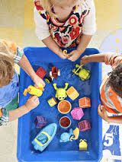  …toys in the water tray….  How many will there be if we add 1 more?  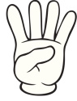 4 + 2  = 6 | No formal method to record these practical examples. Children will be using all sorts of equipment to investigate. Observations made on iPad and photos to support by Teacher and TA.
Addition  Pictorial Representations | Either number sentences represented by pictures…..  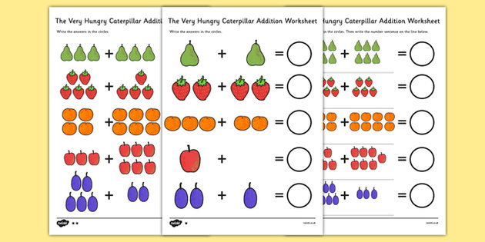  Or word problems also represented with pictures. E.g. There are 3 children on the carpet, one more sat down. How many children are on the carpet? | These will mostly be pictorial representations   + =  Or concrete apparatus modelling the addition of two numbers/combining sets.  Written digits may represent the totals.
Counting on using a number line | Add 6 and 3  What is the sum of 20 and 8?  27 + 7 = | 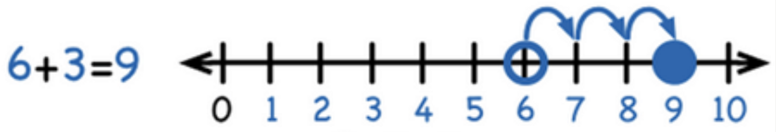  Numberlines will be given to the children either to use practically or to draw the jumps on. Numberlines will start at zero at first. Children will progress to drawing their own numberlines and making the start number the lowest number in the addition calculation: e.g. 23+8, the numberline will be drawn and starting number will be 28.
Rounding and adjusting on a numberline | 27 + 19 =  Adjusting is used when a number near a multiple of 10 is added, e.g. 19. 31 etc. It is more efficient to add the multiple of 10 and adjust accordingly. | 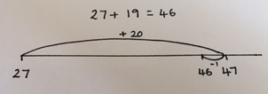
Partitioning to add on a numberline | 42 + 36 = | 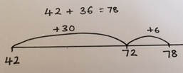
Partitioning to add | What is 46 add 32? | Partition the numbers into tens and units:  40 + 6  30 + 2  70 + 8 = 78  Setting the calculation out like this leads into the next stage more effectively.
Expanded Vertical Column Addition | 67 + 24 | 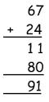  Here the numbers must be put into columns: tens, units etc. Only one digit can be put in each square. The units must be added first then the tens. Although this makes no difference in the expanded method, it is really important to start with the units first as they progress through the methods.
Subtraction  Stage Name | Subtraction  Examples | Subtraction  Method of Recording
Practical Examples | To find one less 4-2 =  To take away within 10. | No formal method to record these practical examples. Children will be using all sorts of equipment to investigate (including their fingers). Observations made on iPad and photos to support by Teacher and TA.
Pictorial Representations | We made six cakes, Mrs Jones ate 3 of them. How many were left? | These will mostly be pictorial representations  = 3  Concrete apparatus models six objects and taking away two objects.  Written digits represent objects.
Subtraction/Finding the difference, on a numberline. | 6 - 3  What is difference between 22 and 13? | 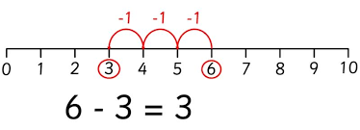  Numberlines will be given to the children either to use practically or to draw the jumps on. Numberlines will start at zero at first. Children will progress to drawing their own numberlines and the first number on the right side/end, then count the jumps back down the numberline: e.g. 23-8, the numberline will be drawn like this:  28
Partitioning to subtract | 46 – 32 = | Partition the numbers into tens and units:  40 + 6  -30 + 2  10 + 4 = 14  Setting the calculation out like this leads into the next stage more effectively.
Expanded Vertical Column Subtraction | 67 - 24 | Here the numbers must be put into columns: tens, units etc. Only one digit can be put in each square. The units must be subtracted first then the tens. Although this makes no difference in the expanded method, it is really important to start with the units first as they progress through the methods.  67 – 24  60 + 7  - 20 + 4  3  40  43

Multiplication  Stage Name | Multiplication  Examples | Multiplication  Method of Recording
Practical Examples | Doubling using the language of multiplication | No formal method to record these practical examples. Observations made on iPad and photos to support by Teacher and TA.
Pictorial Representations | How many lots/groups of 2 are there?  How many pairs of feet are there?   | These will mostly be pictorial representations.  XX  XX  XX  How many groups of two are there?  Use of concrete apparatus for children to visibly count and see. Extend to written digital representation.
Repeated Addition on a number line | 4 x3 = 3 + 3 + 3 + 3 =  I have four pairs of trainers, how many trainers do I have altogether? | 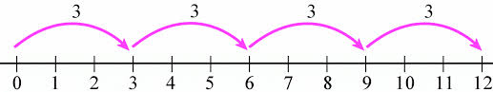  Numberlines will be given to the children either to use practically or to draw the jumps on. Children will progress to drawing their own numberlines.
Arrays and Repeated Addition | Multiply 4 by 5  How many fives in 25?  In the shop there were five pizzas in each row and three rows. How many pizzas were there altogether? | 4 x 5  4 x5 = 20 5 x 4 = 20

Division  Stage Name | Division  Examples | Division  Method of Recording
Practical Examples | How can we halve these sweets? | No formal method to record these practical examples. Observations made on iPad and photos to support by Teacher and TA.
Pictorial Representations | If I share 15 cakes between 3 people – how many cakes do they all get? | These will mostly be pictorial representations.  Extend to written digits underneath.
Repeated Subtraction on a number line | 15 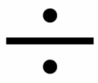 3 =  There are 15 sweets shared between 3 people, how many sweets do they each get? | 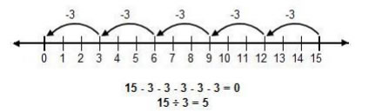  Numberlines will be given to the children either to use practically or to draw the jumps on. Children will progress to drawing their own numberlines. They start at the total number and jump back in groups of the divider – the answer is the number of jumps.

